|  |  |  |  |  |  |  |  |  |  |  |
| --- | --- | --- | --- | --- | --- | --- | --- | --- | --- | --- |
| **Software Requirement Specifications**  Hotel Management System  Version: [1.0]   |  |  | | --- | --- | | Project Code | SE-2002 | | Supervisor | Miss Syeda Rubab Jaffar | | Co Supervisor | Miss Zarnain Maryam Awan | | Project Team | 22k-4818 Mustafa Masood  22k-5195 Laiba Fatima  22k-5198 Sabina Rasheed | | Submission Date | 22 March 2024 | |

Document History

|  |  |  |  |
| --- | --- | --- | --- |
| **Version** | **Name of Person** | **Date** | **Description of change** |
| 1 | Laiba Fatima | 15 March | Document Created, Introduction |
| 2 | Sabina Rasheed | 15 March | Added Distribution List, Overall System Description |
| 3 | Laiba Fatima | 16 March | Added External Interface Requirements |
| 4 | Sabina Rasheed | 16 March | Added Functional Hierarchy |
| 5 | Sabina Rasheed | 17 March | Added Use Cases 4.1.1 - 4.1.6 |
| 6 | Mustafa Masood | 18 March | Modified Use Case 4.1.4, Added Use Case 4.1.7 |
| 7 | Sabina Rasheed | 18 March | Added Use Case Diagram |
| 8 | Mustafa Masood | 20 March | Added Non-Functional Requirements |
| 9 | Laiba Fatima | 20 March | Added References and Appendices |
| 10 | Mustafa Masood | 22 March | Document Review and Submission |

Distribution List

|  |  |  |
| --- | --- | --- |
| **Name** | **Role** | |
| Miss Syeda Rubab Jaffar | | Supervisor |
| Miss Zarnain Maryam Awan | | Co- Supervisor |

Document Sign-Off

|  |  |  |
| --- | --- | --- |
| **Version** | **Sign-off Authority** | **Sign-off Date** |
| 1.0 | Miss Syeda Rubab Jaffar |  |
| 1.0 | Miss Zarnain Maryam Awan |  |
|  |  |  |
|  |  |  |
|  |  |  |
|  |  |  |
|  |  |  |

**Table of Contents**

*1.* *Introduction …………………………………………………………………………**…..7*

*1.1.* *Purpose of Document …………………………………………………………………7*

*1.2.* *Intended Audience …………………………………………………………………….7*

*1.3*  *Abbreviations ………………………………………………………………………......7*

*1.4.* *Document Convention ………………………………………………………………...7*

*2.* *Overall System Description ………………………………………………………**…..8*

*2.1.* *Project Background ………………………………………………………………... ...8*

*2.2.* *Project Scope ………………………………………………………………....……….8*

*2.3.* *Not In Scope* *………………………………………………………………**.....………. 8*

*2.4.* *Project Objectives* *………………………………………………………………....…8*

*2.5.* *Stakeholders* *………………………………………………………………....….……. 9*

*2.6.* *Operating Environment ……………………………………………………………**…..9*

*2.7.* *System Constraints* *………………………………………………………………....…9*

*2.8.* *Assumptions & Dependencies ……………………………………………………...10*

*3.* *External Interface Requirements* *……………………………………………**…..…11*

*3.1.* *Hardware Interfaces ………………………………………………………………....11*

*3.2.* *Software Interfaces* *………………………………………………………**…..…**….. 11*

*3.3.* *Communications Interfaces ……………………………………………….......……11*

*4.* *Functional Requirements …………………………………………………………... 12*

*4.1.* *Functional Hierarchy ………………………………………………………………... 12*

*4.1.1 Room Management ………………………**…..……………………………………... 12*

*4.1.2 Customer Management …………………………..………………………….……... 12*

*4.1.3 Food Management …………………………..…………………………………….... 13*

*4.1.4 Booking Management …………………**….…..……………………………………... 14*

*4.1.5 Payment Collection ………………………**…..…………………………………….... 15*

*4.1.6 House Keeping …………………........………..……………………………………... 15*

*4.1.7 Reporting ……………………….................**…..……………………………………... 16*

*4.2.* *Use Cases ………………………………………………………………....…**…..…. 17*

*4.2.1.* *Room Reservation………………………………………………………………....…19*

*4.2.2.* *Payment Collection………………...……………………………………………....…20*

*4.2.3.* *Order Food……………………………………............…………………………....…21*

*4.2.4.* *Update Room Inventory…...……………………………………………………....…22*

*5.* *Non-functional Requirements ……………………………………………………….22*

*5.1.* *Performance Requirements ……………………………………………………**….. 21*

*5.2.* *Safety Requirements ……………………………………………………………**….. 23*

*5.3.* *Security Requirements ……………………………………………………………....23*

*5.4.* *User Documentation ………………………………………………………………... 23*

*6.* *References ………………………………………………………………....…….…. 23*

*7.* *Appendices ………………………………………………………………....……**….. 23*

1. Introduction

The Hotel Management System is a tool for booking rooms of hotel through online process by the customer.

* 1. Purpose of Document

The main purpose of this document is to illustrate the requirements of the project Hotel Management System. This document describes the design decisions, architectural design and the detailed design needed to implement the system. It provides visibility in the design and provides information that is essential for software support. The document provides a detailed description of functional and nonfunctional requirements put forward by the client.

* 1. Intended Audience

*The intended audience for this Hotel Management System document is the project stakeholders, including developers, project managers, and quality assurance teams involved in the development and implementation of the Hotel Management System. The people who will benefit from the final product are the Receptionist, Customer and Administration.*

**1.3**   **Abbreviations**

SRS Software Requirements Specification

HMS Hotel Management System

*TCP - Transmission Control Protocol*

*IP - Internet Protocol*

JDK - Java Development Kit

JRE - Java Runtime Environment

IDE - Integrated Development Environment

REQ - Requirement

* 1. Document Convention

Font used for this document is “Arial Italic” for paragraphs and “Arial Bold Italic” for Headings and Sub-Headings. Sizes are different for every type of text; for the title the size is 16, sub-headings are size 12 and for the text written in paragraphs the size is 10.

1. Overall System Description
   1. Project Background

*The Hotel Management System emerges from the necessity within the hospitality industry for a more efficient and user-friendly solution to manage hotel operations. With the evolution of technology and changing customer expectations, there is a need for a comprehensive system that streamlines reservations, check-ins/check-outs, room assignments, billing, and reporting. The project is initiated to enhance operational efficiency, improve guest experience, and optimize resource utilization within the hotel. This document will be used as a base document for further project management.*

* 1. Project Scope

*The hotel management system aims to provide comprehensive management functionalities for hotel operations. It includes functionalities such as room management, customer management, food management, and backup and recovery. The system will facilitate booking, allocation, deallocation of rooms, and ordering of food items. It will also incorporate automatic backup and recovery features to ensure data integrity and system reliability.*

*The software to be produced will help the customers of the Hotels to reserve rooms and other facilities of the hotel from anywhere. The core part of the project is the reservation and the booking system to keep track of the reservations and room availability. This will be explained in detail in ‘3 – Functional Requirements’ section. There are three types of end-users for this Hotel Management System. The first ones are the customer who uses the system for the reservation purposes. The other end users are the admin user and the management users who are given separate authentication to the Hotel Management System.*

*The booking module is used to reserve the hotel rooms. The customer can book the rooms online or by phone or in person. The customer needs to enter their personal details to confirm booking.*

* 1. Not In Scope
* Integration with external systems such as accounting software.
* Advanced security features like biometric authentication.
  1. Project Objectives

*The project aims to streamline hotel operations by providing an efficient and user-friendly management system. It will automate various tasks involved in room booking, customer management, and food ordering, thereby enhancing operational efficiency and improving customer experience. The result of the project will be a robust hotel management system that meets the needs of both hotel staff and guests.*

* 1. Stakeholders
* *Business Users: Hotel managers, receptionists, and staff responsible for managing room bookings and customer interactions.*
* Customers: Guests staying at the hotel who will interact with the system for room bookings and food orders.
* Technical Team: Developers, testers, and system administrators involved in software development, testing, and maintenance.
  1. Operating Environment

The product will be operational with its full functionalities under the following hardware and software requirements.

SOFTWARE:

* *Project is a desktop bases application*
* *Language: JAVA*
* Windows environment will be ideal for all features to run smoothly.
* Great performance is also compatible on MacOS and Linux systems.
* *JDK / JRE and IntelliJ IDE*

* 1. System Constraints
* *The system must adhere to coding standards and software development best practices.*
* *The system's performance may be limited by the hardware resources available.*
* *The system should support multiple languages to accommodate diverse cultural backgrounds of users.*
* *Ensure that the software does not infringe on any copyrights, trademarks, or patents.*
* *Consideration of the physical environment where the software will be deployed, such as noise levels, temperature, and humid*
* *Tailoring the system's features and functionalities to meet the preferences and expectations of the target user demographic.*
* *Managing dependencies effectively to avoid conflicts and compatibility issues during development and deployment.*
  1. Assumptions & Dependencies
* The project should be completed within specified time including Planning, Designing, Development, Testing and Deployment.
* *The project should be completed within a specified budget.*
* *The Requirement Traceability Matrix (RTM) should be completed.*
* *All the Entry and Exit criteria of all the stages should be met.*
* *The product should be user-friendly, reliable and should maintain industry standards without compromising the quality.*
* *The system architecture and design should be open and in a standard way such that additional functionalities can be added later without much effort.*

1. External Interface Requirements

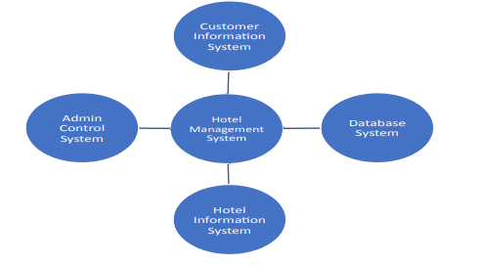

Context Diagram of External Interfaces

* 1. Hardware Interfaces

Printers will be used to print customers’ bills and order details. The hotel should have computers on which employees will check customer details and these computers should have RAM of 4GB or more and intel core i3 chips or more. The customer will have to use a computer with at least 4GB of RAM or an Android phone – iOS phones will also work

* 1. Software Interfaces

The customer will have to use a computer with a window operating system or Mac. Operating system and Android 7 above devices can be used for booking. The Hotel should have computers on which the employees will check and get details of booking of customer and these computers should also use latest Windows or Mac.

* 1. Communications Interfaces

*The System shall be using HTTP/HTTPS for communication over the Internet and for intranet communications, it shall use TCP/IP protocol. It will also include email notifications for booking confirmations, SMS notifications for guest reminders.*

1. Functional Requirements
   1. Functional Hierarchy

Following encompasses the functions in Hotel Management System

* + 1. ***Room Management***
       1. *Description and Priority*

*Room Management is a fundamental feature of the hotel management system, essential for*  *organizing and managing room inventory efficiently.*

* + - 1. *Stimulus/Response Sequences*
* *The system displays room availability and details.*
* *Users can check room availability based on criteria such as room type.*
* *Guests can book available rooms for specified dates.*
* *Receptionists can allocate rooms to guests upon check-in and deallocate them upon check-out.*
  + - 1. *Functional Requirements*
* *REQ-1.1: Display room details including type, capacity, amenities, and rates.*
* *REQ-1.2: Check room availability based on specified criteria.*
* *REQ-1.3: Allow guests to book available rooms for specified dates.*
* *REQ-1.4: Enable receptionists to allocate and deallocate rooms as per guest requirements.*
  + 1. ***Customer Management***
       1. *Description and Priority*

*Customer Management is crucial for maintaining a database of guest information, preferences,*  *and interactions, enabling personalized services and fostering customer loyalty.*

* + - 1. *Stimulus/Response Sequences*
* *The system collects and stores guest information during booking and check-in processes.*
* *Staff can access guest profiles to provide personalized services and fulfill specific requirements.*
* *The system sends automated communication such as booking confirmations, welcome messages, and post-stay feedback requests to guests.*
  + - 1. *Functional Requirements*
* *REQ-2.1: Capture and store guest information, including contact details, preferences.*
* *REQ-2.2: Allow guests to update their profiles with personal preferences and special requests.*
* *REQ-2.3: Provide staff with access to guest profiles for personalized service delivery.*
* *REQ-2.4: Automate communication with guests through emails or SMS, including booking confirmations, welcome messages, and post-stay feedback requests.*
  + 1. ***Food Management***
       1. *Description and Priority*

*Food Management facilitates ordering and managing food services for guests during their stay,*  *enhancing their overall experience*

* + - 1. *Stimulus/Response Sequences*
* *The system displays the food menu with options and prices.*
* *Guests can place food orders for delivery to their rooms or dining areas.*
* *Staff receives and processes food orders, ensuring timely delivery.*
* *Food charges are calculated and added to the guest's bill.*
  + - 1. *Functional Requirements*
* *REQ-3.1: Display the food menu with options and prices.*
* *REQ-3.2: Allow guests to place food orders for delivery or dining.*
* *REQ-3.3: Process food orders received from guests and ensure timely delivery.*
* *REQ-3.4: Calculate food charges and add them to the guest's bill.*
  + 1. ***Booking Management***
       1. *Description and Priority*

*Booking Management facilitates the reservation of rooms and associated services, ensuring*  *smooth check-in and check-out processes.*

* + - 1. *Stimulus/Response Sequences*
* *Users can view available rooms and select preferred options.*
* *Guests provide necessary details for room reservation, including dates and preferences.*
* *The system confirms room bookings and provides booking references.*
* *Receptionists manage check-in and check-out processes, allocating rooms and processing payments.*
  + - 1. *Functional Requirements*
* *REQ-4.1: Display available rooms and associated details for booking.*
* *REQ-4.2: Allow guests to provide necessary details and preferences for room reservation.*
* *REQ-4.3: Confirm room bookings and provide booking references to guests.*
* *REQ-4.4: Enable receptionists to manage check-in and check-out processes, allocating rooms and processing payments.*
  + 1. ***Payment Collection***
       1. *Description and Priority*

*Payment Collection is essential for processing guest payments for room bookings, additional*  *services, and miscellaneous charges incurred during their stay.*

* + - 1. *Stimulus/Response Sequences*
* *The system displays the total amount due for the guest's stay, including room charges, food orders, and any additional services.*
* *Guests provide payment details and choose their preferred payment method (e.g., cash, credit card, online payment).*
* *Staff members process the payment and issue receipts to guests.*
* *The system updates the guest's account and generates invoices for reference.*
  + - 1. *Functional Requirements*
* *REQ-5.1: Calculate the total amount due for the guest's stay, considering room charges, food orders and additional services.*
* *REQ-5.2: Accept payment from guests through various methods such as cash, credit card, or online payment.*
* *REQ-5.3: Generate receipts for guests upon successful payment processing, detailing the payment amount and method.*
* *REQ-5.4: Update the guest's account with the payment details and maintain a record of transactions for future reference.*
  + 1. ***House Keeping***
       1. *Description and Priority*

*Housekeeping Management is essential for maintaining cleanliness and tidiness throughout the*  *hotel premises, ensuring a comfortable and hygienic environment for guests.*

* + - 1. *Stimulus/Response Sequences*
* *The system generates housekeeping tasks based on room occupancy status and guest requests.*
* *Housekeeping staff receive task assignments on their mobile devices or through a centralized system.*
* *Staff members update task statuses upon completion, including cleaning, restocking amenities, and attending to maintenance issues.*
  + - 1. *Functional Requirements*
* *REQ-6.1: Generate housekeeping tasks based on room occupancy status, guest requests, and scheduling priorities.*
* *REQ-6.2: Assign tasks to housekeeping staff and provide them with detailed instructions and room status information.*
* *REQ-6.3: Enable staff members to update task statuses, indicating completion and any relevant notes or observations.*
* *REQ-6.4: Allow supervisors to track task progress, reassign tasks if needed, and ensure service standards are met consistently.*
  + 1. ***Reporting***
       1. *Description and Priority*

*Reporting functionalities provide insights into hotel operations, including occupancy rates,*  *revenue performance, guest feedback.*

* + - 1. *Stimulus/Response Sequences*
* *Managers can access reports through a dashboard interface, allowing them to analyze trends, identify opportunities for improvement, and make data-driven decisions.*
* *Reports may include guest feedback analysis, highlighting areas of satisfaction and areas for improvement in service quality.*
  + - 1. *Functional Requirements*
* *REQ-7.1: Generate standard reports on hotel performance metrics, including occupancy rates, revenue, and profitability.*
* *REQ-7.2: Provide customizable reporting options, allowing managers to tailor reports to specific needs and preferences.*
* *REQ-7.3: Incorporate guest feedback analysis into reports, identifying trends, and areas for service improvement.*
* *REQ-7.4: Include operational reports on housekeeping efficiency, maintenance issues, and staff performance metrics for internal evaluation and optimization.*
  1. Use Cases

*All use cases follow the following format:*

*For Customer use case: C - #*

*For Admin use case: Ad - #*

*For Receptionist use case: R - #*

*For Staff use case: St - #*

*Use case diagram for Hotel Management System:*

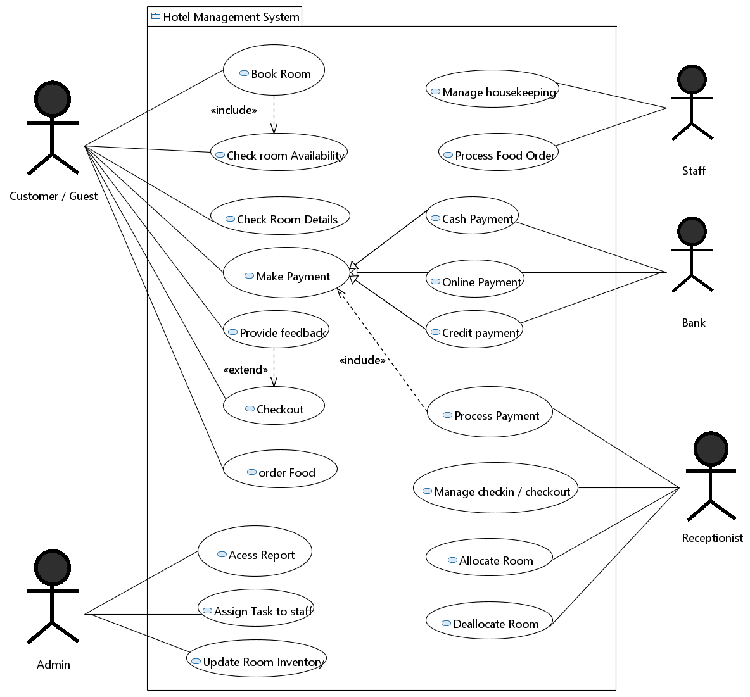

* + 1. Room Reservation:

|  |  |  |  |  |
| --- | --- | --- | --- | --- |
| *C – 001: Book Room* | | | | |
| **Use case Id:** | | C - 001 | | |
| **Actors:**  Customer, Receptionist, Admin | | | | |
| **Feature:** Booking Management | | | | |
| **Pre-condition:** | | Availability of vacant rooms. | | |
| **Scenarios** | | | | |
| **Step#** | **Action** | | | **Software Reaction** |
| **1.** | Customer will login the system and navigates to booking options | | | System presents booking options |
| **2.** | Customer shall look and browse for the rooms of choice. | | | System displays available rooms for selection |
| **3.** | Customer selects desire room and proceeds | | | System confirms room selection and notify admin |
| **4.** | Customer proceeds to payment interface | | | System prompts payment options |
| **5.** | Customer confirms booking | | | System notifies customer via email and booking detail is updated in inventory |
| **Alternate Scenarios:** | | | | |
| **1a:** If a customer inputs incorrect login cred*en*tials, the system will show an error message and prompt them to enter the correct information again  **2a:** *Admin shall cancel request if the room is not available*  **2b:** *Customer will be notified about unavailability of desired room and showed alternative options* | | | | |
| **Post Conditions** | | | | |
| **Step#** | **Description** | | | |
| **1.** | Room booked successfully | | | |
| **2.** | **Room not available** | | | |
| **Use Case Cross referenced** | | | No specific cross references | |

* + 1. ***Payment Collection:***

|  |  |  |  |  |
| --- | --- | --- | --- | --- |
| *R – 001: Collect Payment* | | | | |
| **Use case Id:** | | R - 001 | | |
| **Actors:** Customer, Receptionist | | | | |
| **Feature:** Payment Processing | | | | |
| **Pre-condition:** | | Bill generated according to facilities used | | |
| **Scenarios** | | | | |
| **Step#** | **Action** | | | **Software Reaction** |
| **1.** | Receptionist retrieves customer’s bill | | | System presents bill to the customer |
| **2.** | Receptionist confirms payment method | | | System prompts for payment method confirmation |
| **3.** | Customer provides payment details | | | System validates payment information |
| **4.** | Customer proceeds to payment interface | | | System prompts payment options |
| **5.** | Admin shall update record | | | System updates the database |
| **6.** | Receptionist process payment | | | System confirms successful payment |
| **Alternate Scenarios:** | | | | |
| ***3a****: Customers provide invalid payment details system prompts to enter correct details*  ***3b****: Customers lacks sufficient funds System notifies receptionist*  *4a: Receptionist accidentally enters an incorrect payment amount. System detects the discrepancy and alerts the receptionist to correct the payment amount before finalizing the transaction.* | | | | |
| **Post Conditions** | | | | |
| **Step#** | **Description** | | | |
| **1.** | Payment collected successfully | | | |
| **2.** | Receipt generated | | | |
| **Use Case Cross referenced** | | | No specific cross references | |

* + 1. ***Order Food***

|  |  |  |  |  |
| --- | --- | --- | --- | --- |
| *C – 002: Order Food* | | | | |
| **Use case Id:** | | C - 002 | | |
| **Actors:** Customer | | | | |
| **Feature:** Food Management | | | | |
| **Pre-condition:** | | System shall be updated with the latest food menu | | |
| **Scenarios** | | | | |
| **Step#** | **Action** | | | **Software Reaction** |
| **1.** | *Customers browse through the menu* | | | System presents menu to the customer |
| **2.** | *Customer selects and place order* | | | System prompts for payment method confirmation |
| **3.** | *Admin is notified about the order* | | | System prompts payment options |
| **4.** | *Admin forwards the order to restaurant.* | | | System updates the database |
| **5.** | *Customer will be notified that order is placed.* | | | System confirms successful payment |
| **Alternate Scenarios:** | | | | |
| **2a:** *Customer selects items that are not available system notifies about unavailability of food item*  **2b:** *Customer cancels the order system updates the inventory accordingly* | | | | |
| **Post Conditions** | | | | |
| **Step#** | **Description** | | | |
| **1.** | Order placed successfully | | | |
| **2.** | Order ready to serve | | | |
| **Use Case Cross referenced** | | | No specific cross references | |

* + 1. ***Update Room Inventory***

|  |  |  |  |  |
| --- | --- | --- | --- | --- |
| *Ad – 001: Update Inventory* | | | | |
| **Use case Id:** | | Ad - 001 | | |
| **Actors:** Admin | | | | |
| **Feature:** Booking Management | | | | |
| **Pre-condition:** | | Room service checks and marks the missing items in the system | | |
| **Scenarios** | | | | |
| **Step#** | **Action** | | | **Software Reaction** |
| **1.** | Admin reviews the list of missing items reported by room service. | | | System presents the list of missing items. |
| **2.** | Admin updates the inventory records with the missing items. | | | System updates the database with the inventory changes. |
| **3.** | Admin verifies the updated inventory. | | | System confirms successful update of inventory. |
| **4.** | Housekeeping shall place the missing items and update the record in system | | | System verfies record |
| **Alternate Scenarios:** | | | | |
| **1a:** Item is short in general inventory, housekeeping forwards the request to ADMIN to restock.  *2a: Admin finds discrepancies in reported missing items. System prompts admin to verify and correct the list.*  *3a: Admin encounters system error while updating inventory. System alerts admin about the error and prompts to retry or contact support.* | | | | |
| **Post Conditions** | | | | |
| **Step#** | **Description** | | | |
| **1.** | Room inventory is updated, and system is updated. | | | |
| **2.** | *Admin verifies the inventory* | | | |
| **Use Case Cross referenced** | | | No specific cross references | |

1. Non-functional Requirements
   1. Performance Requirements

* Response time: Average response time shall be less than 2 seconds.
* Throughput: The system shall accommodate 100 booked per minute.
* Recovery Time: In case of system failure, redundant system shall resume operations within 30 seconds. Average repair time shall be less than 1 hour.
* Start-up/Shutdown Time: The system shall be operational within 1 minute of starting up.
* Capacity: The system accommodates 500 concurrent users.
  1. Safety Requirements
* Database should be backed up every hour.
* Under failure, system should be able to come back at normal operation under an hour
  1. Security Requirements
* All external communications between the data’s server and client must be encrypted
* All data must be stored, protected or protectively marked to prevent unauthorized access
* Payment Process should use HTTP over Secure protocol to secure the payment transactions
  1. User Documentation

In our user manual, we are going to keep the information regarding our product which can be understood by a new person who is going to use it. If a new person is using it, online help will be provided; in that we are going to explain each step clearly by our product can be useful for any user. There will be a video tutorial for the new user to get acquainted with the environment of the system.

1. References

* *Software Engineering 9th Edition, Ian Sommerville*
* *Fundamentals of Database System, 6th Edition, Ramez Elmasri, Shamkant B. Navathe*
* *Requirement Engineering: http://morse.inf.unideb.hu/valseg/gybitt/07/ch02.html*
* *Hotel Management System: https://www.scribd.com/doc/63824633/Hotel-ManagementSystem*
* *Case Study: https://www.scribd.com/doc/27927992/Hotel-Management-Case-Study*
* *Requirement Engineering: https://en.wikipedia.org/wiki/Requirements_engineering*

1. Appendices

No information to be added